SIMATS ENGINEERING

ASSESSMENT TOOL 1

COURSE NAME: Artificial Intelligence COURSE CODE: CSA17

COURSE OUTCOME COVERED
CO5: Design AI-based systems using PySpark, RDD operations, and intelligent agent architectures, using scalable systems and integrate components in distributed AI applications. (BTL 5)
Assessment Tool Weightage: 50%

Duration : 1 Hour
QUESTIONS: 5 Total Marks:50
Annexure A

Design Task

Code of Conduct:

I (Name / Reg No) certify that this submission is my original work and that I have adhered to the guidelines specified for this assessment.
I understand that any violation of academic integrity rules will result in disciplinary action.

Signature of the student:

Annexure A

Design Task

Hybrid AI Recommendation Engine Design
Design a hybrid AI-based recommendation system that integrates content-based and collaborative filtering techniques using PySpark RDDs. Explain how distributed data processing can be used to handle large-scale user-item interactions, and describe the role of intelligent agents in adapting recommendations based on user behavior and feedback in real time.

Smart Disaster Detection System
Develop a distributed AI system using PySpark and RDD operations to detect natural disasters (such as floods or earthquakes) from multi-source data streams (satellite images, sensors, and social media). Describe the system architecture, data fusion techniques, and how intelligent agents coordinate to provide early warnings and response strategies.

AI-Based Fraud Detection Framework
Design a scalable fraud detection system using PySpark RDDs to process large volumes of financial transactions. Explain how anomaly detection algorithms can be implemented in a distributed manner and how intelligent agents collaborate to identify suspicious patterns, trigger alerts, and continuously improve detection accuracy.

Autonomous Supply Chain Optimization System
Construct a distributed AI system using PySpark for optimizing supply chain operations (inventory, logistics, demand forecasting). Describe how RDD transformations support large-scale data processing and how multiple intelligent agents interact to make decentralized decisions for cost minimization and efficiency improvement.

Personalized Learning Analytics Platform
Design an AI-driven educational platform that uses PySpark and RDDs to analyze student learning behavior and performance data. Explain how the system supports adaptive learning through intelligent agents, real-time feedback, and scalable analytics to personalize content delivery for thousands of learners.

RUBRICS FOR CALCULATION

Evaluation Criteria | Problem Underst anding &  Require ment  Analysis | System  Architect ure  Design | Use of  PySpark & RDD  Operatio ns | Intelligen t Agent  Integratio n | Scalabilit y &  Distribut ed  Computin g Design | Data Flow &  Processin g Pipeline | Innovatio n &  Creativity | Clarity,  Presentati on &  Document ation
Weightage | 10% | 20% | 15% | 15% | 10% | 10% | 10% | 10%

Criteria | Excellent (5) | Good (4) | Average (3) | Poor (2)
Problem | Clearly defines
Understanding & | problem, | Mostly
Requirement | objectives, and | clear with | Basic | Unclear or
Analysis | constraints | minor gaps | understanding | incorrect
 | Complete,
 | scalable, well- | Good
System | structured | design with
Architecture | architecture | minor | Basic design,
Design | with diagrams | issues | lacks detail | Poor/incomplete
 | Efficient and
 | correct use of
 | RDD | Mostly
Use of PySpark & | transformation | correct | Limited or
RDD Operations | s/actions | usage | partial use | Incorrect/missing
 | Strong
 | integration
Intelligent Agent | with clear agent | Good |  | Poor/no
Integration | roles and logic | integration | Basic integration | integration
 | Clearly
 | addresses
Scalability & | scalability, fault | Covers
Distributed | tolerance, | most | Limited
Computing Design | parallelism | aspects | consideration | Not addressed
 | Clear, logical,
Data Flow & | and well-
Processing | defined data | Mostly
Pipeline | flow | clear | Some gaps | Poorly defined

Innovation & Creativity | Highly  innovative,  realistic, and impactful  solution | Some  innovation | Basic idea | No originality
Clarity,  Presentation & Documentation | Very clear, neat diagrams, well-organized  report | Mostly clear | Somewhat organized | Poor presentation

1. Hybrid AI Recommendation Engine Design
Objective
Design a recommendation system that combines Content-Based Filtering and Collaborative Filtering to recommend products, movies, courses, or other items to users.
System Architecture

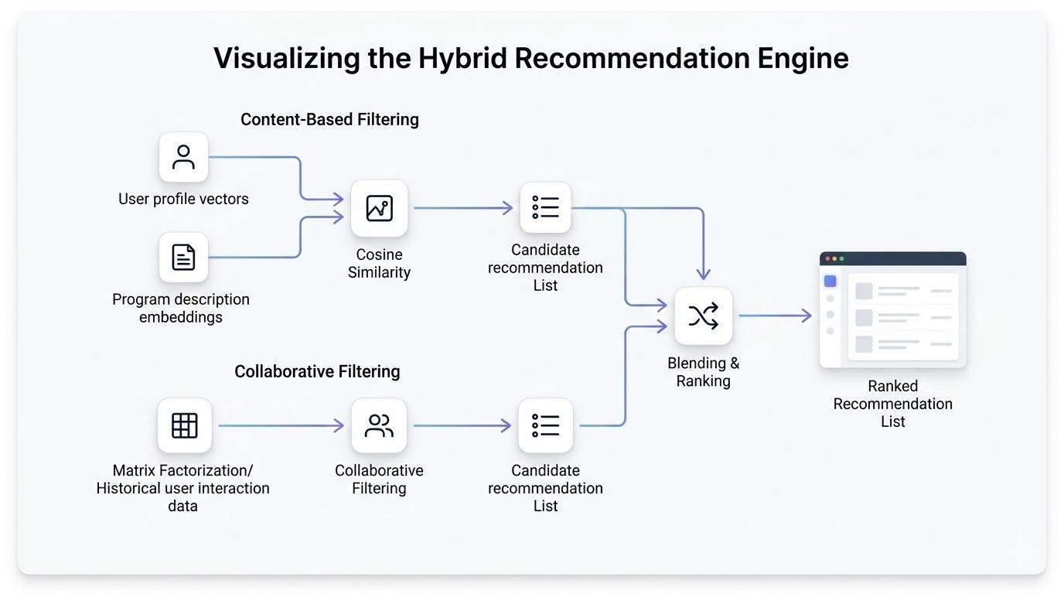

Architecture:
User Data + Item Data + User Feedback
↓
Data Collection Layer
↓
Distributed Storage
↓
PySpark RDD
↓
Data Preprocessing
↓
┌────────┴────────┐
↓ ↓
Content-Based Collaborative
Filtering Filtering
↓ ↓
└────────┬────────┘
↓
Hybrid Recommendation
↓
Intelligent Agent
↓
Personalized Results
↓
User Feedback
└──────────→ RDD Update
Data Used
- User ID
- Item ID
- Ratings
- Clicks
- Purchase history
- Search history
- Item category
- Item description
- User preferences
- Feedback
PySpark RDD Processing
RDDs can distribute millions of user-item interactions across multiple worker nodes.
from pyspark import SparkContext

sc = SparkContext("local", "RecommendationSystem")

data = sc.textFile("ratings.csv")

ratings = data.map(lambda x: x.split(","))

user_items = ratings.map(
lambda x: (x[0], (x[1], float(x[2])))
)
Content-Based Filtering
Items are represented using features such as category, keywords, price, or description.
items = ratings.map(
lambda x: (x[1], x[3])
)

item_features = items.mapValues(
lambda x: set(x.lower().split())
)
The system compares the user's preferred item features with available items.
Collaborative Filtering
Users having similar behavior can be identified.
user_ratings = ratings.map(
lambda x: ((x[0], x[1]), float(x[2]))
)

item_users = ratings.map(
lambda x: (x[1], x[0])
)
Users who interact with similar items can receive similar recommendations.
Hybrid Recommendation
The scores from both methods are combined:
Hybrid Score =
0.6 × Collaborative Score +
0.4 × Content Score
The weights can be changed according to system performance.
Important RDD Transformations
RDD Operation | Purpose
map() | Transform records
filter() | Remove invalid data
flatMap() | Extract multiple features
groupByKey() | Group interactions
reduceByKey() | Aggregate ratings
join() | Combine user/item information
sortByKey() | Rank recommendations
Role of Intelligent Agents
An intelligent recommendation agent continuously monitors:
- User clicks
- Purchases
- Ratings
- Search queries
- Skipped recommendations
- Recently viewed items
The agent updates the user's preference profile and changes recommendation scores.
Workflow
User Behavior
↓
Monitoring Agent
↓
Behavior Analysis
↓
Recommendation Agent
↓
Update User Profile
↓
Generate New Recommendations
↓
Collect Feedback
↺
Advantages
- Handles millions of users and items.
- Distributed processing reduces processing time.
- Combines advantages of both filtering techniques.
- Intelligent agents provide dynamic personalization.
- Easily scalable using additional Spark workers.

2. Smart Disaster Detection System
Objective
Develop a distributed AI system that detects disasters such as floods, earthquakes, cyclones, and landslides using satellite data, sensor data, and social-media information.
System Architecture

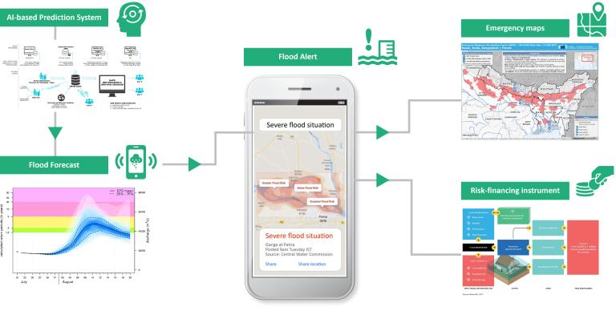
5
Satellite Images ──────┐
│
IoT Sensors ───────────┤
↓
Social Media ─────→ Data Collection
↓
Distributed Storage
↓
PySpark RDD
↓
Data Preprocessing
↓
Feature Extraction
↓
Data Fusion
↓
AI Disaster Detection
↓
Intelligent Agents
↓
Risk Classification
↓
Early Warning System
↓
Authorities + Public + Rescue Teams
Input Data
Satellite Data
- Water coverage
- Cloud patterns
- Land movement
- Temperature
- Vegetation changes
Sensor Data
- Water level
- Seismic activity
- Rainfall
- Temperature
- Pressure
Social Media
- Emergency posts
- Location information
- Disaster-related keywords
- Images/videos
PySpark RDD Processing
from pyspark import SparkContext

sc = SparkContext("local", "DisasterDetection")

sensor_data = sc.textFile("sensor_data.csv")
satellite_data = sc.textFile("satellite_data.csv")
social_data = sc.textFile("social_media.csv")
Sensor Processing
sensors = sensor_data.map(lambda x: x.split(","))

high_risk = sensors.filter(
lambda x: float(x[2]) > 80
)
For example, unusually high water-level readings can indicate a possible flood.
Social Media Processing
posts = social_data.flatMap(
lambda x: x.split()
)

disaster_words = ["flood", "earthquake", "landslide"]

alerts = posts.filter(
lambda x: x.lower() in disaster_words
)
Data Fusion
Different sources are combined to increase reliability.
Satellite Evidence
+
Sensor Evidence
+
Social Media Evidence
↓
Data Fusion
↓
Risk Score
Example:
Risk Score =
0.5 × Sensor Evidence +
0.3 × Satellite Evidence +
0.2 × Social Evidence
If the score crosses a threshold, the system generates an alert.
Intelligent Agents
1. Monitoring Agent
Continuously monitors incoming data.
2. Detection Agent
Identifies abnormal patterns.
3. Verification Agent
Checks whether multiple sources support the disaster prediction.
4. Warning Agent
Sends warnings to authorities and affected people.
5. Response Agent
Suggests actions such as evacuation and rescue deployment.
Workflow
Data Sources
↓
Monitoring Agent
↓
Detection Agent
↓
Data Fusion
↓
Risk Estimation
↓
Verification Agent
↓
Warning Agent
↓
Emergency Response
Advantages
- Early disaster detection.
- Processes huge amounts of data.
- Combines multiple information sources.
- Reduces false alarms through data fusion.
- Supports rapid emergency response.

3. AI-Based Fraud Detection Framework
Objective
Design a scalable system that detects fraudulent financial transactions using distributed PySpark RDD processing and anomaly detection.
System Architecture

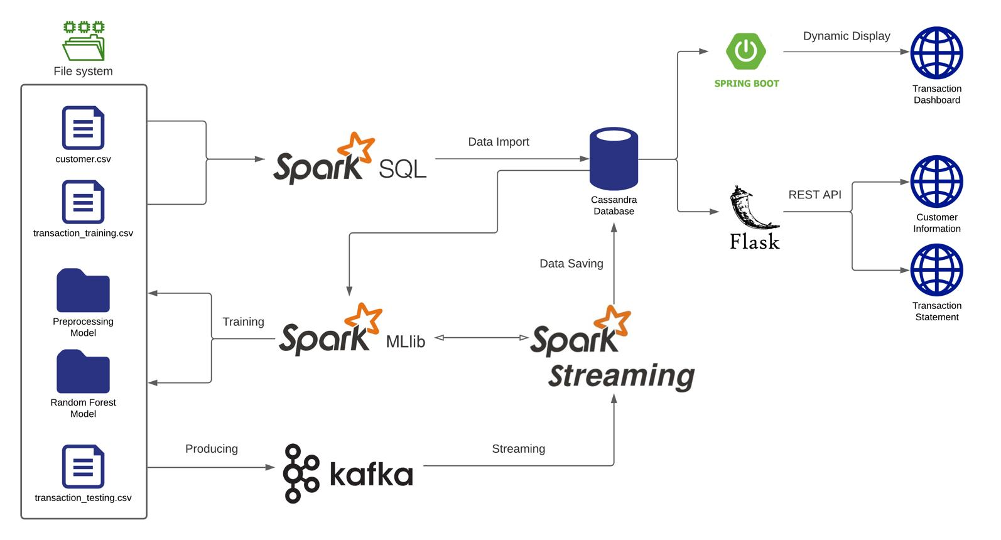
5
Financial Transactions
↓
Data Collection
↓
Distributed Storage
↓
PySpark
↓
RDDs
↓
Data Cleaning & Processing
↓
Feature Extraction
↓
Distributed Anomaly Detection
↓
Fraud Risk Scoring
↓
Intelligent Agents
↓
Alert Generation
↓
Investigation / Blocking
↓
Feedback
↺
Transaction Data
Each transaction may contain:
Transaction ID
User ID
Amount
Time
Location
Merchant
Device
Payment Method
Transaction Frequency
PySpark RDD Implementation
from pyspark import SparkContext

sc = SparkContext("local", "FraudDetection")

data = sc.textFile("transactions.csv")

transactions = data.map(
lambda x: x.split(",")
)
Remove Invalid Transactions
valid = transactions.filter(
lambda x: float(x[2]) > 0
)
Calculate User Spending
user_amount = valid.map(
lambda x: (x[1], float(x[2]))
)

total_amount = user_amount.reduceByKey(
lambda a, b: a + b
)
Anomaly Detection
The system identifies unusual behavior such as:
- Very large transaction
- Many transactions in a short time
- Transaction from unusual location
- New device
- Unusual merchant
- Multiple failed transactions
Example:
average = user_amount.map(
lambda x: x[1]
).mean()
Transactions significantly above the normal spending pattern can be marked as anomalies.
Distributed Processing
Transactions are divided across Spark partitions:
Transactions
↓
┌──────────┼──────────┐
↓ ↓ ↓
Worker 1 Worker 2 Worker 3
↓ ↓ ↓
Detection Detection Detection
└──────────┼──────────┘
↓
Fraud Results
Intelligent Agents
Transaction Monitoring Agent
Monitors every transaction.
Anomaly Detection Agent
Calculates the fraud probability.
Investigation Agent
Examines suspicious transaction patterns.
Alert Agent
Generates alerts for high-risk transactions.
Learning Agent
Uses confirmed fraud/non-fraud feedback to improve the model.
Example Decision
Transaction
↓
Risk Score = 0.92
↓
Score > 0.80
↓
HIGH RISK
↓
Generate Alert
↓
Request Verification / Block
Continuous Learning
New Transaction
↓
Prediction
↓
User/Bank Feedback
↓
Confirmed Fraud?
↓
Update Training Data
↓
Retrain Model
Advantages
- Processes millions of transactions.
- Detects fraud quickly.
- Distributed RDD processing improves scalability.
- Intelligent agents automate investigation.
- Feedback continuously improves accuracy.

4. Autonomous Supply Chain Optimization System
Objective
Design a distributed AI system that optimizes inventory, transportation, logistics, and demand forecasting using PySpark and intelligent agents.
System Architecture

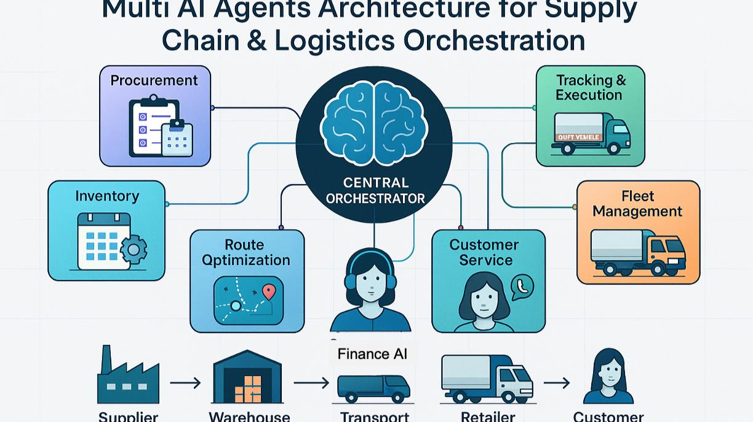
5
Sales Data ───────────┐
│
Inventory Data ───────┤
│
Supplier Data ────────┤
↓
Transportation Data → Data Collection
↓
Distributed Storage
↓
PySpark RDD
↓
Data Preprocessing
↓
Demand Forecasting
↓
Inventory Analysis
↓
Logistics Optimization
↓
Intelligent Agents
↓
Autonomous Decisions
↓
Suppliers / Warehouses / Vehicles
↓
Feedback
↺
Input Data
- Historical sales
- Current inventory
- Supplier information
- Delivery time
- Transportation cost
- Warehouse capacity
- Customer demand
- Fuel cost
- Product prices
PySpark RDD Processing
from pyspark import SparkContext

sc = SparkContext("local", "SupplyChain")

sales = sc.textFile("sales.csv")

sales_rdd = sales.map(
lambda x: x.split(",")
)
Calculate Product Demand
product_sales = sales_rdd.map(
lambda x: (x[1], int(x[2]))
)

total_sales = product_sales.reduceByKey(
lambda a, b: a + b
)
Filter High-Demand Products
high_demand = total_sales.filter(
lambda x: x[1] > 1000
)
Demand Forecasting
Historical sales data can be processed to predict future demand.
Historical Sales
↓
PySpark RDD
↓
Feature Extraction
↓
AI Forecasting Model
↓
Future Demand
The predicted demand is used to determine how much stock should be maintained.
Inventory Optimization
Predicted Demand
↓
Current Inventory
↓
Calculate Stock Difference
↓
If Inventory < Required Stock
↓
Generate Purchase Order
Intelligent Agents
Demand Agent
Predicts future customer demand.
Inventory Agent
Maintains appropriate stock levels.
Logistics Agent
Selects efficient delivery routes.
Supplier Agent
Selects suppliers based on cost, quality, and delivery time.
Warehouse Agent
Manages warehouse capacity and product movement.
Coordinator Agent
Coordinates decisions among all agents.
Multi-Agent Interaction
Coordinator Agent
/ | \
/ | \
Demand Agent Inventory Logistics
Agent Agent
|
Supplier Agent
Example:
Demand Agent:
"Demand for Product A will increase."

↓

Inventory Agent:
"Current stock is insufficient."

↓

Supplier Agent:
"Supplier B has lowest effective cost."

↓

Logistics Agent:
"Route 2 provides fastest delivery."

↓

Coordinator:
"Order from Supplier B using Route 2."
Cost Optimization
The system attempts to minimize:
Total Cost =
Inventory Cost
+ Transportation Cost
+ Ordering Cost
+ Shortage Cost
Advantages
- Reduces excess inventory.
- Prevents stock shortages.
- Reduces transportation cost.
- Improves demand forecasting.
- Enables decentralized decision-making.
- Scales to large supply-chain datasets.

5. Personalized Learning Analytics Platform
Objective
Design an AI-based educational platform that analyzes student behavior and performance using PySpark RDDs and provides personalized learning recommendations through intelligent agents.
System Architecture
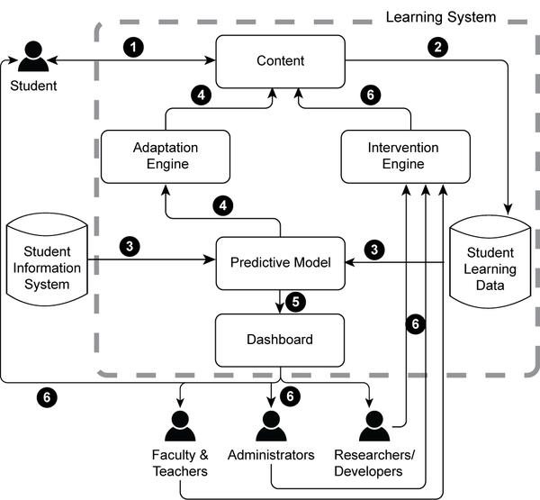

Student Activity
↓
┌─────┼─────────┐
↓ ↓ ↓
Quiz Videos Assignments
↓ ↓ ↓
Clicks Time Scores
└─────┼─────────┘
↓
Data Collection
↓
Distributed Storage
↓
PySpark RDD
↓
Data Preprocessing
↓
Learning Analytics
↓
Student Performance Prediction
↓
Intelligent Learning Agent
↓
Personalized Content
↓
Student Feedback
↺
Data Collected
The platform can collect:
- Student ID
- Course ID
- Quiz scores
- Assignment marks
- Video watching time
- Number of attempts
- Login frequency
- Completed lessons
- Questions answered
- Topics where students make mistakes
- Student feedback
PySpark RDD Processing
from pyspark import SparkContext

sc = SparkContext("local", "LearningAnalytics")

data = sc.textFile("student_activity.csv")

students = data.map(
lambda x: x.split(",")
)
Calculate Student Scores
scores = students.map(
lambda x: (x[0], float(x[2]))
)

total_scores = scores.reduceByKey(
lambda a, b: a + b
)
Identify Low-Performing Students
weak_students = total_scores.filter(
lambda x: x[1] < 50
)
Learning Behavior Analysis
The system analyzes:
Video Time
+
Quiz Scores
+
Assignment Scores
+
Attempts
+
Activity Frequency
↓
Student Learning Profile
For example:
Student A
Quiz Score = 85%
Video Completion = 90%
Attempts = Low
↓
Advanced Content
Whereas:
Student B
Quiz Score = 45%
Video Completion = 60%
Attempts = High
↓
Revision Material
+ Practice Questions
+ Additional Explanation
Adaptive Learning
The platform dynamically selects learning content.
Student Performance
↓
Performance Analysis Agent
↓
Identify Strengths & Weaknesses
↓
Recommendation Agent
↓
Select Learning Material
↓
Student
↓
New Performance Data
↺
Intelligent Agents
1. Monitoring Agent
Tracks student activity.
2. Performance Agent
Analyzes marks and learning progress.
3. Recommendation Agent
Selects appropriate learning materials.
4. Feedback Agent
Provides immediate feedback.
5. Motivation Agent
Encourages students who show low engagement.
6. Coordinator Agent
Coordinates the activities of all agents.
Real-Time Feedback
Suppose a student repeatedly gets questions about arrays wrong.
Quiz Attempt
↓
Wrong Answers Detected
↓
Performance Agent
↓
Identify Weak Topic: Arrays
↓
Recommendation Agent
↓
Basic Array Tutorial
↓
Practice Questions
↓
New Quiz
If the student improves:
Basic → Intermediate → Advanced
If the student continues struggling:
Revision → Examples → Practice → Assessment
RDD Operations Used
RDD Operation | Application
map() | Transform student records
filter() | Identify weak/strong students
reduceByKey() | Calculate scores
groupByKey() | Group activities by student
join() | Combine student and course data
flatMap() | Extract learning activities
sortByKey() | Rank performance
Scalability
Thousands of students generate millions of learning events.
PySpark divides the data into partitions:
Student Data
↓
PySpark Cluster
┌──────────┼──────────┐
↓ ↓ ↓
Worker 1 Worker 2 Worker 3
Students Students Students
↓ ↓ ↓
Analytics Analytics Analytics
└──────────┼──────────┘
↓
Combined Results
↓
Personalized Learning
This allows the platform to process large amounts of student activity efficiently.
Advantages
- Supports thousands of learners.
- Provides personalized content.
- Identifies weak topics automatically.
- Provides real-time feedback.
- Uses distributed processing for scalability.
- Intelligent agents continuously adapt learning paths.

